How the Milky Way became spiral?

Astronomers have long known that the Milky Way is a spiral galaxy. But how did our home galaxy get its beautiful spiral arms?
A simulation run on the GreenPlanet supercomputer cluster at the University of California, Irvine suggests its spiral structure may have been triggered by an act of cosmic violence: a series of collisions with a dwarf galaxy.

Dwarf galaxy, big impact
Since 1994, it’s been known that the Sagittarius Dwarf galaxy—named after the constellation in which it appears from Earth—is in a polar orbit around the Milky Way and in the process of merging with our galaxy. In 2003, infrared telescopes and supercomputers that traced the orbital motions of its stars revealed that the Sagittarius Dwarf had actually collided with the Milky Way twice—once 1.9 billion years ago and again 0.9 billion years ago—and that it is now coming in for a third collision in just another 10 million years.
Until recently, most investigators have been studying how the Milky Way’s tremendous gravitational field and tidal forces are ripping the Sagittarius Dwarf into long streamers of stars.
In computations for his dissertation research, however, former Irvine graduate student Chris Purcell asked a different question: What effects did the repeated collisions of the Sagittarius Dwarf, with its invisible but massive halo of dark matter, have on the larger Milky Way itself?

Dark matter, visible results
Ordinary matter makes up only 4.6 percent of the cosmic density; only 0.5 percent is visible. Nearly five times that much—23 percent—of the universe is made of invisible, transparent “dark matter,” whose existence is felt through its gravitational influence. It is now known that every galaxy, including the Sagittarius Dwarf (pre-collision) and our own Milky Way, resides at the center of a giant halo of dark matter several times larger in radius and many times greater in mass.
Pre-collision, the Sagittarius Dwarf was quite large—somewhere in number of stars between the Small and Large Magellanic Clouds (the Milky Way’s two irregular galaxy companions visible to the naked eye from the southern hemisphere). But its dark matter mass likely exceeded the mass of all the visible stars in the Milky Way.
“When all that dark matter first smacked into the Milky Way like a ghostly belly flop, 80 to 90 percent of it was stripped off,” Purcell explained. “But the whirling disk of stars that was the Milky Way at that time was a very tenuous, chaotic system. That first impact produced instabilities that were amplified and quickly formed spiral arms and associated ring-like structures in the outskirts of our Galaxy.”
Purcell’s paper, “The Sagittarius impact as an architect of spirality and outer rings in the Milky Way,” which he wrote with four coauthors (including his Irvine dissertation advisor James S. Bullock), has been published as a Letter in the September 15, 2011 issue of Nature.
- Trudy E. Bell, M.A.

Further reading
The full reference to the Nature Letter is: “The Sagittarius impact as an architect of spirality and outer rings in the Milky Way,” by Chris W. Purcell, James S. Bullock, Erik J. Tollerud, Miguel Rocha, and Sukanya Chakrabarti, Nature 477: 301–303, 15 September 2011. The full text is available online from http://www.nature.com/nature/journal/v477/n7364/full/nature10417.html and from http://arxiv.org/abs/1109.2918 and http://xxx.lanl.gov/abs/1109.2918 . Two computer-simulation movies of the impact appear in the press release at http://hipacc.ucsc.edu/MilkyWayImpact.html (scroll down to the bottom).
The University of California High-Performance AstroComputing Center (UC-HIPACC), based at the University of California, Santa Cruz, is a consortium of nine University of California campuses and three Department of Energy laboratories (Lawrence Berkeley Laboratory, Lawrence Livermore Laboratory, and Los Alamos National Laboratory). UC-HiPACC fosters collaborations among researchers at the various sites by offering travel and other grants, co-sponsoring conferences, and drawing attention to the world-class resources for computational astronomy within the University of California system. More information appears at http://hipacc.ucsc.edu .

CAPTIONS:

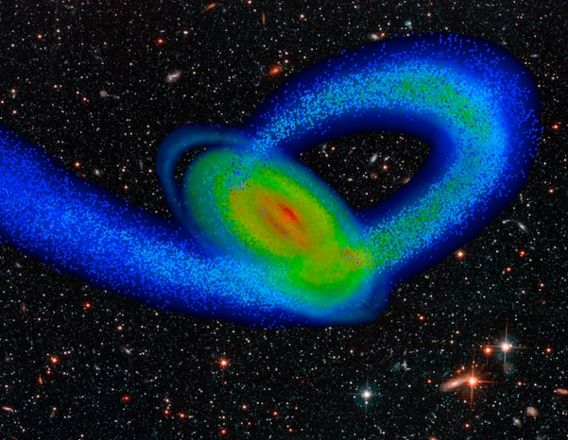
Incoming third impact of the Sagittarius Dwarf galaxy (blue stream of stars) with our Milky Way Galaxy (multicolored disk) was simulated by the GreenPlanet supercomputer cluster at the University of California, Irvine, and rendered by co-author Erik J. Tollerud against a background of galaxies seen in the Hubble Deep Field. Note the simulated disk’s ring-like spiral extensions in the outer Milky Way (upper left), which strongly resemble actual streams found at low latitudes with respect to the disk plane, in the nearby region of the Milky Way viewed from the Earth in the opposite direction from the center of the Galaxy. According to a Letter by Chris W. Purcell and coauthors in the British journal Nature, those spiral arms began to emerge after the initial impact of the Sagittarius Dwarf galaxy nearly two billion years ago.

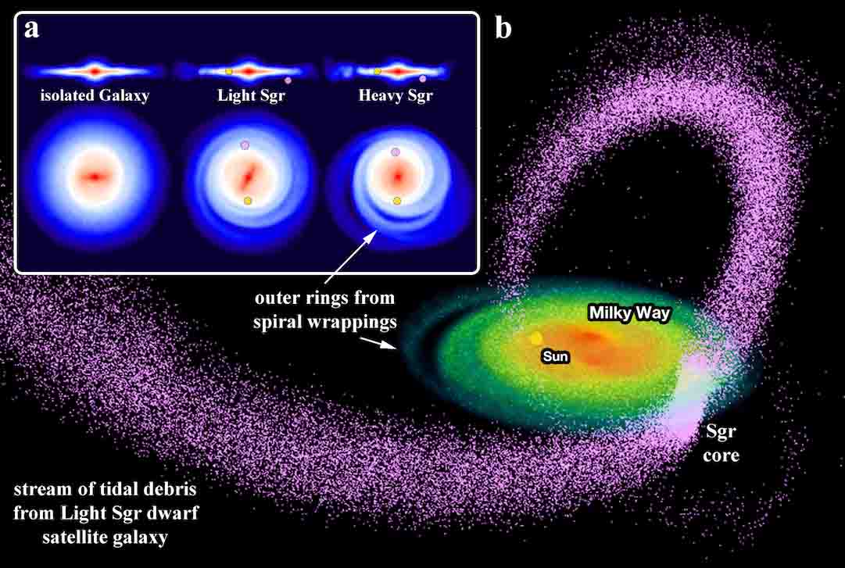
Computer simulations visualized the disk of the Milky Way galaxy for three cases: no impact with a dwarf galaxy, impact with a Sagittarius Dwarf galaxy of lower mass (Light Sgr), and impact with a Sagittarius Dwarf galaxy of higher mass (Heavy Sgr). Our Milky Way galaxy is shown both edge-on and face-on in the inset panels; the sun’s location is marked as a yellow dot and the present location of the Sagittarius dwarf’s remnant core is marked as a pink dot, as shown after more than two billion years of isolated evolution. Shown in the background is a global rendering of the ‘Light Sgr’ tidal debris and the Milky Way disk.

